Assignment 2: Natural language of processing

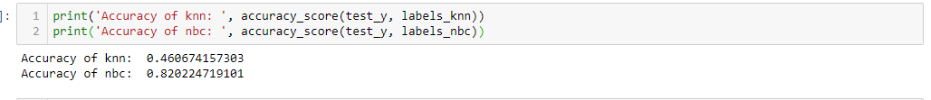

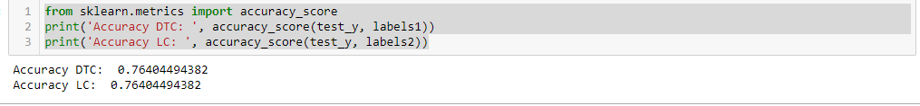

As it is shown in the pictures, The Top three accuracy of my result are from NBC, DTC, and LC

**Code:**

**KNN and NBC:**

from sklearn.neighbors import KNeighborsClassifier

from sklearn.naive_bayes import MultinomialNB

from sklearn.model_selection import train_test_split

from sklearn.metrics import accuracy_score

from sklearn.feature_extraction.text import TfidfVectorizer

from sklearn.feature_extraction.text import CountVectorizer

corpus = open('badges.data').read()

data = corpus.split('\n')

data.remove(data[-1])

data.remove(data[0])

X_label,Y_value=[],[]

for row in data:

label = row[:1]

value = row[2:]

X_label.append(label)

Y_value.append(value)

vec = CountVectorizer(max_features = 20)

matrix_Y = vec.fit_transform(Y_value)

from sklearn.feature_extraction.text import TfidfVectorizer

vectorizer = TfidfVectorizer()

matrix_Y = vec.fit_transform(Y_value)

train_x,test_x,train_y,test_y = train_test_split(matrix_Y,X_label,shuffle=True,train_size = 0.7)

knnc = KNeighborsClassifier(n_neighbors = 5)

nbc = MultinomialNB()

knn.fit(train_x, train_y)

nbc.fit(train_x, train_y)

labels_knn = knn.predict(test_x)

labels_nbc = nbc.predict(test_x)

print('Accuracy of knn: ', accuracy_score(test_y, labels_knn))

print('Accuracy of nbc: ', accuracy_score(test_y, labels_nbc))

**DTC and LC**

**from sklearn.tree import DecisionTreeClassifier**

**from sklearn.model_selection import train_test_split**

**from sklearn.linear_model import SGDClassifier**

**from sklearn.feature_extraction.text import TfidfVectorizer**

**from sklearn.feature_extraction.text import CountVectorizer**

**corpus = open('badges.data').read()**

**X, y = [], []**

**for row in data:**

**label = row[:1]**

**name = row[2:]**

**X.append(name)**

**y.append(label)**

**from sklearn.feature_extraction.text import CountVectorizer**

**vec = CountVectorizer(max_features = 20)**

**matrix_X = vec.fit_transform(X)**

**train_x, test_x, train_y, test_y = train_test_split(matrix_X, y, shuffle = True, train_size = 0.7)**

**dtc = DecisionTreeClassifier()**

**lc = SGDClassifier()**

**lc.fit(train_x, train_y)**

**dtc.fit(train_x, train_y)**

**labels1 = dtc.predict(test_x)**

**labels2 = lc.predict(test_x)**

**from sklearn.metrics import accuracy_score**

**print('Accuracy DTC: ', accuracy_score(test_y, labels1))**

**print('Accuracy LC: ', accuracy_score(test_y, labels2))**